**Lab4: Human Visual System**

Mingqin Dai

**I.Introduction and Motivation**

In this lab, we are going to take a look at Mach bands, a sinusoidal grating, and center/surround fileds for simultaneous contrast and Weber's Law, in order to use this artificial images to evaluate the response of the eye and explain why we see what we see base on widely accepted models of human visual perception. We are doing this lab because a number of image processing operations including sampling below the Nyquist rate, pixel quantization, imperfect interpolation, printing, compression, etc., may introduce objectionable visual artifacts in images. In order to design efficient image processing algorithms, we need to know what artifacts are visible, and how objectionable are these artifacts. And partial answers to these questions are available from studies of the Human Visual Systems(HVS). This lab covers a number of issues which have had a practical impact on the design of image processing systems. After knowing these, we could better solve above image processing problems.

**II.Method and Discussion**

*1.Horizontal and Vertical Mach Band*

We create a 512x512 vertical and horizontal Mach bands containing ­eight bands with same width, which increase linearly in brightness from left to right and top to bottom. In this part, we use Mach bands to demonstrate the eye’s impulse response. The intensity discontinuities that exist at the boundaries between bands cause overshoots and undershoots in perceived brightness.

The Mach bands effect is due to the spatial high-boost filtering performed by the human visual system on the luminance channel of the image captured by retina. And it is independent of the orientation of the boundary. This effect is result from lateral inhibition, a neural process in the retina visual system that enhances the sharpness of edges. Lateral inhibition refers to the fact that neurons caused to fire by a light stimulus will inhibit firing of neighboring neurons. The way in which lateral inhibition could produce the perception of Mach bands is as follows. If the receptive field of a retinal ganglion cell lies entirely within the borders of a band, then both the excitatory center and inhibitory surround are uniformly illuminated with little net effect on their firing. Compared with cell whose inhibitory surround is partially in the darker area to is left, this cell will be less inhibited by the surround and fire at a faster rate resulting in the brain interpreting this as brighter. Figure (a) shows the actual light intensity of Mach band and figure (b) shows the perception of lightness of it. This shows that our eyes intend to exaggerated the contract between edges of the slightly differing shades of gray, as soon as they contact one another, by triggering edge-detection in the human visual system. This visual phenomenon is important to keep in mind when evaluating grayscale images with obvious edges, such as teeth and bones.

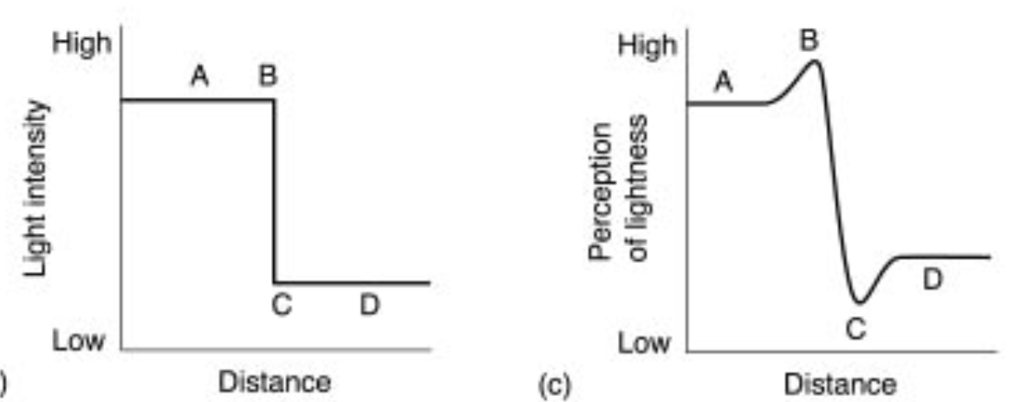

(a)

(b)

*2.sinusoidal Grating*

We create a 512x1024 image by sampling a sinusoid grating with its frequency varies linearly from 0 to $π/3$ from left to right and its amplitude varies linearly from 127.5 to 0 from top to bottom. We use it to analyze the frequency response of the eye.

Based on my perception, the frequency range that contrast the strongest is approximately $(\frac{π}{20},\frac{2π}{15})$, which is approximately between 3 and 10 cycles/degree.(the theoretical spatial frequency region with peak sensitivity.) The amplitude represents the luminance of the sinusoidal grating, where higher amplitude refers to higher luminance. In general, higher amplitude gives higher contrast, contrast sensitivity decreases for lower luminance, especially in high frequency regions. We have lower visual acuity in dark. As the amplitude increases, the size of the frequency range with strong contrast increases. For all amplitudes we test, the peak sensitivities are all occurs at lower frequencies. For the location of the range, based on what I perceived, the location varies slightly to higher frequencies. This indicates that with the decrease in luminance, contrast sensitivity to higher frequency reduces. The spatial impulse samples represent the spatial weighting by the ganglion cells. The Fourier Transform of this response is known as the Modulation Transfer Function(MTF), i.e., the frequency response of the human eye. The plot of contrast sensitivity to spatial frequency indicates that its lesser sensitivity towards both high and low frequencies, the peak is at about 4 to 5 cycles per degree. This indicate that the MTF is similar to the frequency response of a spatially bandpass filter blocking very low and high frequencies.

As distance increases, the frequency range with strong contrast shrinks, which means the size of the frequency range decreases. On the other hand, the location of the peak sensitivity basically does not change. This is because the spatial frequency is expressed in cycles per degree, which is number of cycles of the sinusoidal gratin subtended in one degree of the eye, $cycles per degree of eye=\frac{drπ}{180s}.$ (Let the distance of the observer from the screen where the gratings be presented by *d* inches, the resolution of the screen be *r* pixels per inches, one cycle of the sinusoidal grating be *s* pixel wide.)

*3.Simultaneous Contrast*

We create two 512x512 images next to each other with different “outer squares” intensities and same “inner square” intensities. With different grayscales of two “outer squares” and same grayscales of two “inner squares”, we want to compare the perceived brightness of two “inner squares”.

For both the six combinations of intensities 0,128, and 255 for x and S1, with S2 different from S1 and x, the intensity that I perceived of the two inner rectangles seems have different brightness level. (Though they are exactly the same shade of grey.) For example, with S1=255, S2=70, x=128, the inner rectangle within S1 seems brighter than the inner rectangle within S2. And with S1=255, S2=180, x=128, the inner rectangle within S1 seems brighter than the inner rectangle within S2.

Simultaneous contrast refers to the manner in which the colors of two different objects affect each other. Since we rarely see colors in isolation, simultaneous contrast affects our sense of the color that we see. According to French chemist Michel Eugène Chevreul, in the case where the eye sees at the same time two contiguous colors, they will appear as dissimilar as possible, both in their optical composition (hue) and in the height of their tone (mixture with white or black). The eye has a high, yet limited, ability to discriminate between different light intensity levels. This capability spans an astronomical range of intensity levels: on the order of 10 decades on a logarithmic scale. However, the HVS cannot operate over such a wide range simultaneously. Instead, it accomplishes this variation by adapting its overall sensitivity. The adaption is controlled by the “average” light intensity, which is often dominated by the background.

*4.Weber’s Law*

We create a 512x512 image with intensity I of “outer square” and intensity F of an 8x8 “inner square”. With initial condition F=I, we slowly increase F until we can notice the difference between F and I, $dI=F-I.$

1. *Table*

|  |  |  |  |  |  |  |  |  |  |
| --- | --- | --- | --- | --- | --- | --- | --- | --- | --- |
| I | F | dI | dI/I | ln(I) | I | F | dI | dI/I | ln(I) |
| 0 | 7 | 7 | ∞ | ∞ | 140 | 143 | 3 | 0.0214 | 4.9416 |
| 10 | 13 | 3 | 0.3000 | 2.3026 | 150 | 153 | 3 | 0.0200 | 5.0106 |
| 20 | 22.5 | 2.5 | 0.1250 | 2.9957 | 160 | 164 | 4 | 0.0250 | 5.0752 |
| 30 | 31.8 | 1.8 | 0.0600 | 3.4012 | 170 | 174 | 4 | 0.0235 | 5.1358 |
| 40 | 41.7 | 1.7 | 0.0425 | 3.6889 | 180 | 184 | 4 | 0.0222 | 5.1930 |
| 50 | 52 | 2 | 0.0400 | 3.9120 | 190 | 193 | 3 | 0.0158 | 5.2470 |
| 60 | 61.7 | 1.7 | 0.0283 | 4.0943 | 200 | 204 | 4 | 0.0200 | 5.2983 |
| 70 | 71.8 | 1.8 | 0.0257 | 4.2485 | 210 | 214 | 4 | 0.0190 | 5.3471 |
| 80 | 82 | 2 | 0.0250 | 4.3820 | 220 | 225 | 5 | 0.0227 | 5.3936 |
| 90 | 92 | 2 | 0.0222 | 4.4998 | 230 | 236 | 6 | 0.0261 | 5.4381 |
| 100 | 102 | 2 | 0.0200 | 4.6052 | 240 | 247 | 7 | 0.0292 | 5.4806 |
| 110 | 112 | 2 | 0.0182 | 4.7005 | 250 | 235 | 15 | 0.0600 | 5.5215 |
| 120 | 122 | 2 | 0.0167 | 4.7875 |  |  |  |  |  |
| 130 | 133 | 3 | 0.0231 | 4.8675 |  |  |  |  |  |

*b. F vs I graph*

*c. dI/I vs ln(I) graph*

*d. discussion*

Weber's Law states that the ratio of the increment threshold to the background intensity is a constant. For a certain amount of increment *dI*, it is known as visibility threshold, or equivalently just noticeable threshold, the ratio $\frac{dI}{I}$ is the Weber ratio.

We first take a look at the F vs I graph, F and I has the relationship $F=I+dI$. According to Weber’s law, F and I have linear relationship with intersection dI, which is a constant. The graph I plot above according to the result shows that F and I are linear dependence with each other, which means the result I got is consistent with Weber’s Law.

For the dI/I vs ln(I) graph, the Weber’s Law state that the Weber’s ratio is approximately equal to 0.02 for a wide range of I, however, if I is made very small or very large, the Weber ratio increases. If we work with the logarithm of I instead of I itself, the just noticeable threshold becomes approximately independent of I, $\frac{d(lnI)}{d(I)}=\frac{1}{I}$, thus $Δ\left(\ln\left(I\right)\right)≈\frac{dI}{I}≈0.02$. The result I got is basically consistent with Weber’s law, $\frac{dI}{I}$ within I= 80 to I=220 are approximately 0.02, And For very small or large I, the Weber’s ratio increases. However, compared with the graph on the class note, for lower I, namely I=20 to I=70, the Weber’s ratio is somehow too large compared with 0.02. I think this is because I itself is too small in this range. With $dI≈2$, the ratio increases rapidly as I decrease. This cause the error in this range.

*5.General*

The three applications are as follows.

a. Pixelization artifacts on computer screen technique requires the Fourier transform version of the model, which is called "Modulation Transfer Function" to calculate the fundamental frequency of the digitized image which can be visible for human.‬

b. Camera sensor also requires the Modulation Transfer Function to adjust the resulting image contrast, which is one of the essential properties of the camera sensor. ‬

c. Similarly, the digital imaging lens utilize the Modulation Transfer Function to reproduced the object contrast to increase the accuracy. ‬

**III.Results**

What were your results? What did you learn?

In this lab, we study Human Visual System(HVS), which is useful to design efficient image processing algorithms. This lab contains neurophysiology study of HVS and we perform 4 physical test on HVS components, including Mach band, frequency response of eyes, simultaneous contrast and Weber’s Law. Many of the effects in this lab are due to the response of your retinal cells, and take place long before the image reaches your visual cortex. The human visual system employs its own complex image processing paradigms. Human eye is sensitive to contrast rather than light intensity (luminance) (Mach Bands, Simultaneous Contrast). The eye’s spatial frequency response, Modulation Transfer Function(MTF) is bandpass (Frequency response of eyes). The perceived change in stimuli is proportional to the initial stimuli (Weber’s Law).